Business Case©
For [Project Name]
Goal:

Business: Prove that there is a need (or opportunity) (DEMAND) for the (IT) Product or Service

Research: Name the Core/Primary Research Problem by stating the reasons why it exists, the impact it is having on Society, Industry, business or an individual (s) and the timeframes within which it must be resolved.
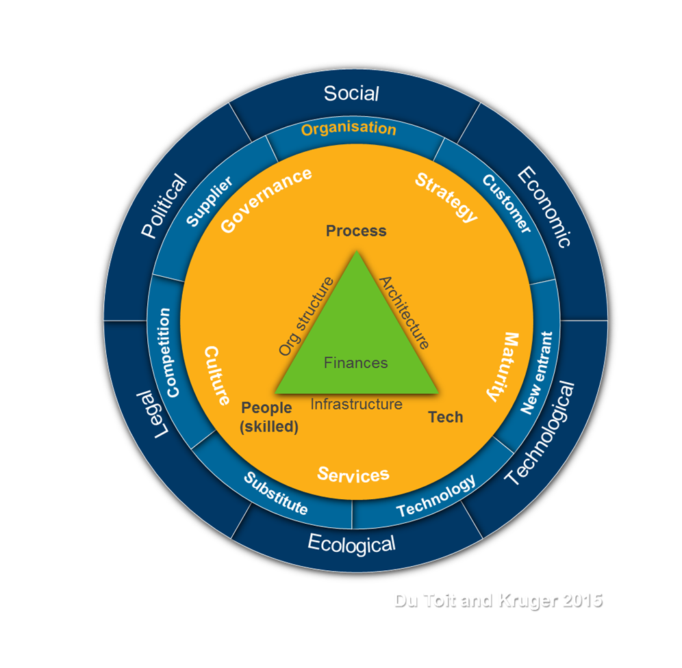

Document Control

Document Information
 | Information
Document ID | [Document Management System #]
Document Owner | [Owner Name]
Issue Date | [Date]
Last Saved Date | [Date]
File Name | [Name]

Document History
Version | Issue Date | Changes
[1.0] | [Date] | [Section, Page(s) and Text Revised]

Document Approvals
Role | Name© | Signature | Date
Project Sponsor

Project Review Group

Project Manager©

Quality Manager
[if applicable]

Procurement Manager
[if applicable]

Communications Manager
[if applicable]

Project Office Manager
[if applicable]

Executive Summary
(Write your Executive Summary LAST, after you have completed the rest of the Business Case).

From a Business and/or research Perspective: State the Primary Business/Research Problem/Opportunity and, briefly discuss the SETTING of the problem/opportunity (i.e, is the problem/opportunity situated in society, an industry, organisation, or at an individual level? And to what extent do these Forces play a role in the CONTEXT of solving the research/business problem? Within this larger business context, justify how (you intend- AIM) to solve the problem, or exploit the opportunity, and how this will satisfy the NEEDS of primary and secondary.

Business Problem Analysis (Start of Research process)

2.1 ANALYSIS: MACRO FORCES (Opportunities and Threats)

Objective: Understanding the extent to which Political, Economic, Social, Ecological, Legal, and Technological Forces caused or in any way affected the research problem/opportunity.

Research questions:
- To what extent did MACRO FORCES cause the Problem or create the Opportunity?
- What Opportunities and Threats do these Forces present to the ability to solve the problem or exploit the opportunity?
- Will the Solution satisfy the needs of these PESTEL stakeholders?

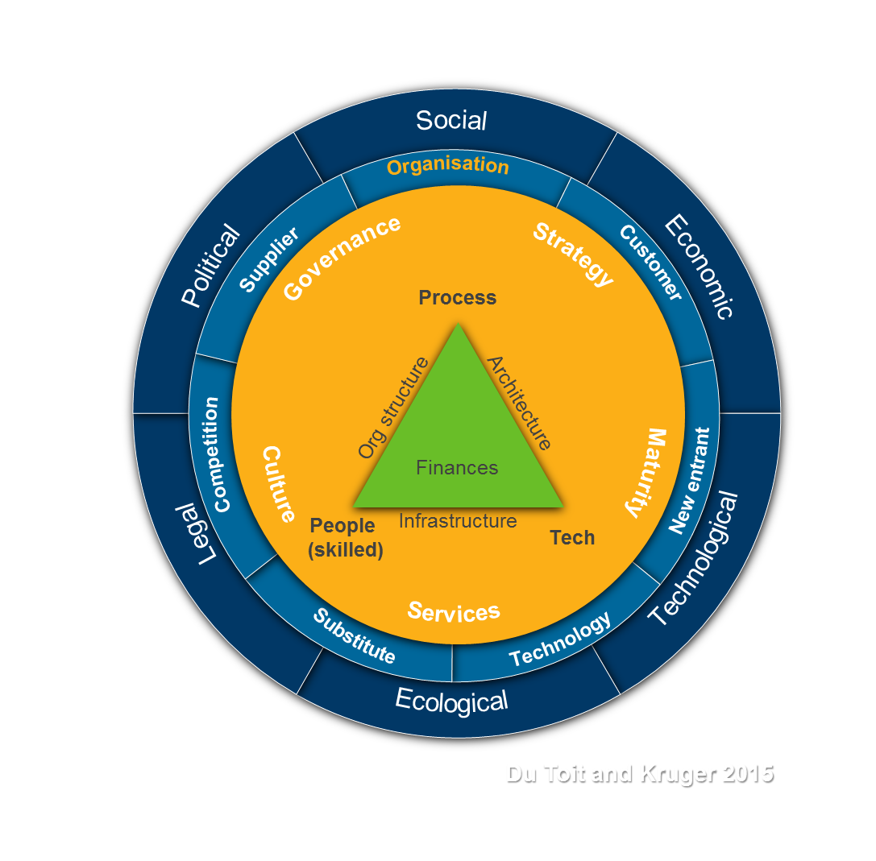

Research Tools:
Literature review / Questionnaires/ Structured questionnaires.

2.2 MICRO-LEVEL ENVIRONMENTAL ANALYSIS

Objective: Understanding the extent to which industry-specific forces such as Customers, Suppliers, Competitors/ New entrants, Substitute products or services caused or in any way affected the research problem/opportunity.

Research questions:
- Is there a need (Customers) in the industry to solve the research problem or to act on the opportunity?
- Are there Competitors (Supply appetite) that are capable (and competent) to solve the problem, or act on the opportunity?
- In solving the problem or acting on the opportunity, are there suppliers that can provide the necessary resources (People, Processes and Technology) to enable the development of solutions?
- Are there substitute products (tea for coffee) or services that can answer the research question, and to what extent will they satisfy the needs of all Stakeholders (PESTEL, Industry, Organisation, Individuals)?
- Are there potential New entrants (with new solutions), or New Technology that can potentially satisfy the needs of Stakeholders?

Research Tools:
Literature review / Questionnaires/ Structured questionnaires.

2 Organisation

Objective: Understanding the extent to which Organisational-specific forces, such as People, Processes, Technology, Governance, Strategy, Maturity, and culture, caused or in any way affected the research problem/opportunity. Given the available time. Identify company-specific strengths and weaknesses that could help address the problem or capitalise on the opportunity.

Research questions:
Given the findings of the PESTEL, Industry and Organisational assessment, is the need that drives the solving of the Research Problem, or the acting on an Opportunity, the result of:
- Opportunities and Threats in the Macro (Pestel), or Micro (Industry) environments presenting strategic challenges to Sustainability (Cost, Focus or Differentiation)?
- Organisational Governance, Risk or Compliance Issues?
- Maturity, or lack thereof, regarding sustainment of current Capabilities (Technology and Processes) and/or Competence (People and skills) to sustain efficient and effective Operations?
- Inability to Service and Modify (Sustain) Business Core and Support Processes, with the necessary People Skills and/or Technology?
- Change in Culture, or cultural issues?

Business Case:  Macro Level  Aim: You need to prove that there is a need (DEMAND) for the (IT) Product or Service in your organisation  i.e., Determine if the product or service will make your organisation or a potential client's organisation grow and/or become more profitable.  Start by analysing if the need is caused or in any way affected by Macro Political, Economic, Social, Ecological, Legal, and Technological Forces, and ESG and DEI Scorecard requirements, i.e.,  Determine:  - What opportunities and Threats Macro forces present to justify the need for the (IT) product or service?  - What is the focus of the intended (IT) product or service, i.e., Cost reduction and/or Differentiation of services?  - Is there a need beyond the organisation for the intended IT product or service? (customers)  - Timeline: Strategic impact over time and the window of opportunity to act on this need. | Business Case:  Micro level  Aim: Once you have proven that there is a demand for the IT product or service, you need to determine supply:  - Are potential vendors already developed or can develop, sell, and maintain such IT products or services? (competition)  - Can substitute products or services also satisfy the required need?  - Are there potential new market entrants that can develop, sell, and maintain such products or services?  - Can suppliers supply the required resources to develop, sell, and maintain IT products or services?  Summarise all findings and deductions and conclude the organisation's strategic need for the Product or Service internally and externally.  If there is no need -discard the idea. (See Business Case Example) | Feasibility  WORK  Aim: Once the need, demand, and supply are confirmed, you need to determine whether your organisation's People are competent and capable of Defining and Architecting Business Processes and Technology to achieve the required software solutions.  As such, you need to  - provide a short description of the business environment and business problems (or opportunities) as per the Business Case  - List the requirements for a solution to the business problem or opportunity by completing the following sections:  - List of Business Drivers  - Feasibility Assessment  - Potential Solutions  Description  Risks  Issues  Assumption  - Feasibility Ranking

Holistic
A
Area of Concern:
Real-world Problems OR Opportunities to solve.
Consensus vs.
Accommodation

F Framework of Ideas
Body of Knowledge
Learning
An intellectual construct, concept, or theory that is being evaluated or applied in the research.

M
Applied
to
Methodology
Research Methods
1.
Challenge

Social
Economic
Technological
Ecological
Legal
Political
Learning about
Challenge:1
Identify the Challenge/Opportunity that must be solved

Context: 2
Define the Context that will inform/influence the resolution of the challenge.

Concepts: 3
Identify the respective Concepts (key elements, success factors, elements or “building blocks”) pertinent to solving the challenge, in as much as it allows for cause-and-effect analyses.

Constructs: 4
Construct the direct and indirect relationships or “issues of systemic interaction” between the different concepts that allow for a “holistic “approach to resolving problems or challenges.

Capacity: 5
Create appropriate content for Capacity and or solutions that will allow for the sustainable resolutions of the challenge through the “Planning Process” for the entire life cycle of the solution(s)

